Introduction
Early fire detection is important for preventing damage to life, property, and the environment. Fire detection systems, which often rely on local heat or smoke sensors, are limited in coverage and scalability, making them insufficient for modern, distributed environments such as residential areas, agricultural lands, and industrial zones. Based on these limitations, this project proposes the development of a system that enables users to detect fires in their own environment via cloud based fire detection and monitoring platforms whether homes, farms, factories or forests through an intelligent, camera integrated mobile application.
The main objective of this project is to design and implement a system that allows users to remotely monitor their areas via connected CCTV cameras, while fire detection is performed automatically by a deep learning model developed from scratch. The cameras stream video data to a cloud environment, where the footage is securely stored and processed. A custom deep learning model, specifically trained for fire and smoke recognition, analyzes the incoming frames in real time to identify fire incidents. Once a potential fire is detected, the system sends a notification to the user’s mobile application, allowing immediate awareness and response. Each user can access and monitor only their own designated areas, ensuring both privacy and control over the viewing process.
The scope of the project involves the full integration of data acquisition, model training, inference, and mobile based visualization. The backend will be implemented on cloud infrastructure such as Amazon Web Services (AWS), enabling scalable video storage, efficient computation, and secure user data management. The deep learning component will be the core of the system, focusing on developing a robust model capable of separate real fire events from false alarms under various environmental conditions. Training will be managed using an extensive dataset collected from real world fire and non fire scenes. The mobile application will serve as the primary interface for users, displaying real time alerts, event history, and live camera feeds
From a hardware perspective, the system no longer relies on embedded devices such as Raspberry Pi. Instead, it operates through network connected IP cameras that transmit video streams directly to the cloud via secure communication protocols. This approach eliminates the need for on site processing units, reduces maintenance costs, and enhances scalability by allowing easy addition of new cameras. All computational tasks, including model inference, data storage, and system management, are handled centrally on cloud servers, ensuring continuous operation and efficient resource utilization.
The project is developed under several practical and environmental constraints. Network latency and bandwidth limitations are key considerations, as video data must be transmitted continuously to the cloud. Cost efficiency will be achieved through the use of optimized cloud resource management. Ensuring data privacy and system reliability are also critical, as the platform handles sensitive visual information from user environments. Furthermore, the fire detection model must maintain high accuracy under challenging conditions such as changing light levels, weather variations, and smoke interference.
In conclusion, this project aims to create an intelligent, scalable, and user-friendly fire de ling remote monitoring and real-time alerts through a mobile application, the proposed system enhances safety, promotes environmental sustainability, and provides a modern, accessible solution for early fire detection across diverse domains.

2. Literature Review
Abstract(BUNU SİLCEZ EN ÜSTE KOYCAZ SADECE)
Early fire detection plays a critical role in protecting human life and reducing environmental and economic losses, especially in environments where traditional sensor-based systems struggle due to limited coverage or delayed reactions. Traditional fire alarms typically rely on smoke, heat, or gas thresholds, which often leads to late detection or false alerts. Recent advances in computer vision, deep learning, and cloud technologies provide new opportunities for building more reliable and scalable fire detection systems.
This study presents a cloud supported fire and smoke detection approach that uses camera images and a deep learning model capable of identifying flame and smoke as separate classes. Unlike traditional systems, the proposed design processes visual data through a remote backend and provides real time mobile notifications to users, enabling faster response and remote monitoring. The literature review examines three main areas: conventional sensor limitations, image based fire detection methods using CNN and Transformer architectures, and cloud edge infrastructures required for real-time deployment.
By combining modern deep learning methods with a lightweight cloud architecture and mobile integration, this study aims to reduce false alarms, increase detection speed, and offer a more practical alternative for real world conditions. The system and supporting review highlight ongoing challenges such as latency, environmental variability, and security concerns, while also demonstrating how current technological approaches can address these issues more effectively.

2.1 Conventional Fire Detection and IoT-Based Systems
Traditional fire detection systems are mainly based on point sensors that measure smoke density, temperature, or gas concentration. In many commercial and residential buildings, the dominant approach is still to use smoke and heat detectors that trigger an alarm when a predefined threshold is exceeded, sometimes combined with simple actuators like sirens or sprinklers [1]. While these systems are relatively cheap and easy to install, they react only after the fire has grown enough to produce noticeable smoke or heat, which can delay early intervention.
With the spread of the IoT, many recent works extend these classical systems using multiple sensors, microcontrollers, and cloud connectivity. For example, some smart fire systems combine temperature, gas, and flame sensors with IoT modules to send alerts to users’ smartphones and automatically activate prevention mechanisms, showing improved detection speed and reduced false alarms compared to single sensor setups [1]. Other studies focus on fire risk monitoring in residential buildings, where IoT sensor networks continuously send data to cloud platforms for analysis and visualization, allowing building designers and operators to track risk levels over time instead of waiting for a single alarm event [2].
On the other hand, multi sensor data fusion has become an important topic. Instead of making a decision from one sensor only, fusion methods combine smoke, heat, and gas measurements using probabilistic or evidence based algorithms. This kind of fusion has been shown to improve early indoor fire detection accuracy and reduce false alarm rates compared to traditional threshold based schemes [3]. Overall, the literature shows that sensor based systems are mature and widely used, but they still suffer from limited coverage, delayed response, and sensitivity to environmental noise such as dust or humidity.
2.2 Image-Based Fire and Smoke Detection with Deep Learning
Because point sensors can miss small or distant fires, researchers started to look at camera based fire detection. Early studies used classical image processing: they attempted to detect flame-like colors in RGB or YCbCr space, track flickering motion, or model smoke texture and movement over time [4]. These rule based algorithms are computationally cheap but very sensitive to lighting changes and dynamic backgrounds. For example, sunset, car headlights, or bright reflections can easily be misinterpreted as flames, while actual fire can be missed if its color or shape differs from the predefined rules.
With the success of deep learning in computer vision, most recent work has moved to Convolutional Neural Networks CNNs and related architectures. A comprehensive review by Elhanashi and colleagues groups these approaches into classification, object detection, and segmentation based methods, and shows that deep learning greatly improves robustness against complex backgrounds and changing illumination compared to classical techniques [5]. Instead of hand crafted rules, CNN based models automatically learn discriminative features for flames and smoke directly from data.
Among object detectors, the YOLO family is very popular for real time fire detection because it balances speed and accuracy. Holding and colleagues propose a combined YOLOv5 and U-Net architecture that detects fire regions and then segments them more precisely, helping to avoid false alarms from fire like objects in the scene [6]. Other works modify the YOLO backbone to better adapt to fire images; Yu and colleagues introduce an improved YOLOv5 model that is lighter but still achieves high detection accuracy on fire datasets, demonstrating that real time performance is possible even on limited hardware [7].
Beyond CNNs, Transformer based models have started to appear in the fire detection literature. Qiao and colleagues propose FireFormer, a Vision Transformer architecture that uses shifted window self attention to capture long-range relationships in surveillance images, improving forest fire detection under challenging conditions such as artificial smoke or cooking smoke in the background [8]. Segmentation based models are also gaining attention. Kwon and colleagues compare several segmentation networks, including YOLOv5 Seg and Mask R CNN, for early fire detection in electric vehicles and show that pixel-level segmentation can better track the spread of flames than simple bounding boxes [9].
Recent studies also emphasize multi-class detection, where flame and smoke are treated as separate classes instead of a single fire label. Multi-scale architectures designed for indoor environments demonstrate that explicitly modeling different fire indicators can improve detection accuracy and robustness against environmental changes such as lighting variation or partial occlusions [12]. Distinguishing between “only smoke,” “only flame,” and “both” provides more meaningful information for real-world decision-making, since smoke-only scenes may indicate early or smoldering fires, while flame plus smoke strongly confirms an active fire.
Despite these advances, modern reviews point out remaining challenges for deep learning based fire detection. Detecting very small fires, dealing with heavy fog, distinguishing smoke from industrial emissions, and generalizing across different camera viewpoints remain open problems. Studies evaluating CNN and YOLO-based pipelines in real time environments show that dataset bias, hardware limitations, and variable lighting conditions still cause false alarms in practice [14, 15].
2.3 Cloud and Edge-Based Architectures for Camera Fire Detection
When cameras are used for fire and smoke detection, an important design decision is where to run the detection model. One option is a pure cloud architecture, where video streams from IP cameras are sent to cloud servers for processing. Cloud providers offer building blocks for this approach. For example, Amazon Web Services provides Kinesis Video Streams for video ingestion, Rekognition Custom Labels for deploying trained models, and messaging services for sending alerts. An AWS public sector example describes such an architecture for detecting wildfire smoke: video is streamed to the cloud, a smoke detection model is applied, and detected events trigger notifications for first responders [11]. This kind of system is attractive because it is easy to scale and can utilize powerful GPUs.
However, cloud only solutions introduce latency and bandwidth issues. In time critical applications, even a few hundred milliseconds of additional delay can matter. Mehari’s thesis compares a cloud only setup with a fog computing architecture and reports that placing computation closer to the cameras can reduce latency from hundreds of milliseconds to a few tens of milliseconds [10]. The downside is increased system complexity, since multiple fog nodes must be maintained and node failures require fallback strategies.
For this reason, many modern designs use hybrid architectures combining edge and cloud computing. In these systems, time sensitive fire detection runs on edge devices such as local gateways or small servers, while the cloud is used for long term storage, analytics, and centralized management. Multi sensor data fusion methods deployed in the cloud indicate that combining data from multiple devices can improve accuracy, but also highlight the importance of bandwidth and resource management as the number of connected devices increases [13]. Overall, the literature suggests that the optimal architecture is a balanced one: edge computing for fast decisions and cloud computing for scalability and coordination.
Another major concern in cloud connected fire detection systems is security and privacy. Live video from homes, industrial facilities, or forests may contain sensitive information. If these streams and detection results travel over the internet, they require strong protection against unauthorized access or tampering. Industry analyses warn that network connected fire detection platforms can become hidden cybersecurity risks if not properly secured. Misconfigurations or weak authentication can allow attackers to disable alarms or inject false detection events [10]. Therefore, encryption, authentication, and secure system design are considered essential requirements for cloud-based fire detection platforms.

2.4 Real-Time Alert Systems and Mobile Application Integration
In modern fire detection systems, providing real time alerts to users has become just as important as detecting the fire itself. For this reason, mobile integration has gained significant importance.Modern IoT based fire alarm systems not only transmit detected fire information to local sirens or alarm panels, but also transmit it to the cloud or a server over the internet and send instant notifications to relevant users via channels such as smartphone applications, SMS or email. Various examples exist in the literature. In one study using the Blynk mobile application, multi-sensor data from a building was transmitted to the cloud in real time, and when a fire was detected, alerts were sent both to users’ smartphones and to the fire department [15]. In another study, a smart home fire safety system was developed by combining multiple sensor data such as flame, smoke, gas with an artificial intelligence-based model, reducing the possibility of false alarms and alerting home residents with mobile alerts.[16]. In addition, another approach using CCTV cameras instead of traditional sensors provided instant push notifications to users through a custom Android application when fire or smoke was detected, offering a multifunctional and comprehensive mobile interface.This system provides instant information about status of the fire through a user-friendly mobile interface, and even allows users to confirm the situation by accessing camera footage through the application. [17]. A more advanced study aimed at firefighting units introduced a web-based application called FV Pocket. This system can measure critical fire parameters such as flame height and heat release rate in real time; and thanks to the integration of deep learning models with mobile or web-based interfaces, it can provide the user with critical information such as not only the presence of a fire but also the size and speed of the flame spread. Since all heavy processing is performed on the cloud, the mobile device functions only as an interface for data upload and result visualization, ensuring fast and efficient operation [18].
Overall, the integration of deep learning based fire detection with IoT and mobile technologies is considered a critical and innovative step in the literature, as it shortens the detection alert response chain in firefighting.

2.5 Identified Gaps in the Literature and This Project’s Contribution
Even though there are many studies on fire detection, the current literature still has several important limitations. One of the main issues is that most of the proposed models are tested under controlled laboratory conditions. Because of this, it is not very clear how well these systems perform in real life situations such as low light environments, bad weather, heavy smoke, or industrial areas where conditions change constantly [4]. This makes the general reliability of these methods somewhat uncertain.
Another common limitation is that most approaches rely only on camera images. Visual based detection can easily be affected by external factors like fog, steam, light reflections, or sudden brightness changes. Deep learning has improved accuracy in the last few years, but mistakes still happen, especially when smoke looks similar to other visual effects in the environment [5].
In addition, many studies mainly focus on giving a simple fire/no fire result and do not talk much about what happens after detection. Real time response, verification, or how the system should behave in different situations are usually not included, even though they are important for practical use [6].
Real time performance is another challenge. Since deep learning models require high computational power, processing delays can occur, especially on low end hardware. Recently, edge computing has been used in some studies to reduce this delay, but the number of such works is still limited and more research is needed [10].
In this project, we aim to address these issues by building a system that can detect both flame and smoke separately using deep learning. Treating flame and smoke as two different classes helps reduce false alarms caused by fog, steam, or other similar visual effects. We also use an edge based or cloud-supported approach to make the model faster and more suitable for real time use. With these improvements, the study contributes to closing some of the gaps found in the literature while also creating a system that can be applied in real environments.

References
[1] A. Rehman et al., “Smart Fire Detection and Deterrent System for Human Savior by Using Internet of Things (IoT),” Energies, vol. 14, no. 17, p. 5500, 2021. [Online]. Available: https://www.mdpi.com/1996-1073/14/17/5500 MDPI
[2] U. I. Abdullahi, W. Zhang, Y. Cao, and G. Irankunda, “Integrating IoT Technology for Fire Risk Monitoring and Assessment in Residential Building Design,” Buildings, vol. 15, no. 8, p. 1346, 2025. [Online]. Available: https://www.mdpi.com/2075-5309/15/8/1346 MDPI
[3] X. Xiang, H. Zhang, Y. Chen, and H. Cheng, “A Multi-Sensor Data-Fusion Method Based on Cloud Computing for Indoor Fire Detection,” Sensors, vol. 22, no. 15, p. 5902, 2022. [Online]. Available: https://www.mdpi.com/1424-8220/22/15/5902 MDPI
[4] A. E. Cetin et al., “Video fire detection – Review,” Digital Signal Processing, vol. 23, no. 6, pp. 1827–1843, 2013. [Online]. Available: https://doi.org/10.1016/j.dsp.2013.07.003
[5] A. Elhanashi, S. Essahraui, P. Dini, and S. Saponara, “Early Fire and Smoke Detection Using Deep Learning: A Comprehensive Review of Models, Datasets, and Challenges,” Applied Sciences, vol. 15, no. 18, p. 10255, 2025. [Online]. Available: https://www.mdpi.com/2076-3417/15/18/10255 MDPI
[6] T. Holding, M. Kampffmeyer, S. A. Sæbø, and R. Jenssen, “Fire Detection and Segmentation using YOLOv5 and U-Net,” in Proc. 29th European Signal Processing Conf. (EUSIPCO), 2021. [Online]. Available: https://eurasip.org/Proceedings/Eusipco/Eusipco2021/pdfs/0000741.pdf Eurasip
[7] D. Yu et al., “Improved YOLOv5: Efficient Object Detection for Fire Images,” Fire, vol. 8, no. 2, p. 38, 2025. [Online]. Available: https://www.mdpi.com/2571-6255/8/2/38 MDPI
[8] Y. Qiao et al., “FireFormer: An Efficient Transformer to Identify Forest Fire from Surveillance Cameras,” International Journal of Wildland Fire, vol. 32, pp. 1364–1380, 2023. [Online]. Available: https://www.publish.csiro.au/WF/WF22220 CSIRO Publishing
[9] H. Kwon, T. Kim, and J. Kim, “Evaluating Segmentation-Based Deep Learning Models for Electric Vehicle Fire Detection,” Fire, vol. 8, no. 2, p. 66, 2025. [Online]. Available: https://www.mdpi.com/2571-6255/8/2/66 MDPI
[10] S. Mehari, “Low Latency Fog Computing Architecture for a Fire Safety Application,” M.Sc. thesis, Linköping Univ., Sweden, 2020. [Online]. Available: https://www.diva-portal.org/smash/record.jsf?pid=diva2%3A1395933 Diva Portal
[11] D. Sheehan, “Detect Wildfire Smoke Using Amazon Rekognition,” AWS Public Sector Blog, Sept. 2023. [Online]. Available: https://aws.amazon.com/blogs/publicsector/detect-wildfire-smoke-using-amazon-rekognition/ Amazon Web Services, Inc.
[12] A. Abdusalomov et al., “A Multi-Scale Approach to Early Fire Detection in Smart Homes,” Electronics, vol. 13, no. 22, p. 4354, 2024. [Online]. Available: https://www.mdpi.com/2079-9292/13/22/4354 MDPI
[13] N. K. Vaegae et al., “Multisensor Fuzzy Logic Approach for Enhanced Fire Detection,” Journal of Sensors, vol. 2024, Article ID 8511649, 2024. [Online]. Available: https://onlinelibrary.wiley.com/doi/10.1155/2024/8511649 Wiley Online Library
[14] B. Özel, M. Gümüşbaş, and F. B. Sevilgen, “Review of Modern Forest Fire Detection Techniques,” Information, vol. 15, no. 9, p. 538, 2024. [Online]. Available: https://www.mdpi.com/2078-2489/15/9/538 MDPI
[15] M. B. M. Noor and M. A. Hashim,“Development of IoT-based Smart Fire Detection System with Real-Time Notification,”IRE Journals, vol. 3, no. 8, pp. 123–129, 2019. [Online]. Available: https://www.irejournals.com/formatedpaper/1707697.pdf
[16] A. M. Khan, M. Faizan, and M. Shoaib, “Smart home fire detection system using AI and IoT,” JIP Publication, vol. 5, no. 2, pp. 215–221, 2021. [Online]. Available: https://jippublication.com/index.php/jip/article/download/225/175
[17] S. Bashir, N. Ahmad, and A. Rehman, “Artificial intelligence based real-time fire detection with IoT integration,” VFAST Transactions on Software Engineering, vol. 8, no. 4, pp.141–147,2020.[Online].Available:https://vfast.org/journals/index.php/VTSE/article/download/2092/1663
[18] T. Wei and Y. Chen, “Fire monitoring using real-time web-based applications,” Fire Technology,2025.[Online].Available:https://link.springer.com/article/10.1007/s10694-025-01738-6

3. Software Requirements Specification

3.1 Introduction

3.1.1 Purpose
The purpose of this Software Requirements Specification (SRS) document is to define the functional and non-functional requirements of a cloud-based fire and smoke detection and alerting system that operates on existing IP camera infrastructures. This document serves as a reference for system developers, project stakeholders, instructors, and evaluators by clearly describing system behavior, constraints, performance expectations, and user interactions.
The SRS provides a structured description of system functionalities, access control rules, alert workflows, performance criteria, and security requirements to ensure a reliable and safe fire detection solution.

3.1.2 Scope
The system described in this document is an AI-assisted fire and smoke detection platform designed to analyze live video streams from IP cameras deployed in buildings, industrial facilities, and designated zones. The system automatically detects potential fire incidents, generates alerts, and supports human-in-the-loop verification through managerial approval.
Key features within the scope of the system include:
- User and role-based access management
- IP camera and zone management
- Real-time fire and smoke detection
- Alert generation and notification workflows
- Controlled live camera access during incidents
- Event logging and reporting
- Mobile application support using BYOD principles
The system does not perform physical fire suppression, firefighting actions, or emergency dispatch operations. It functions solely as a detection, alerting, and decision-support system.

3.1.3 Definitions, Acronyms, and Abbreviations

Term | Description
CCTV | Closed-Circuit Television
IP Camera | Network-enabled video camera
RTSP | Real-Time Streaming Protocol
ONVIF | Open Network Video Interface Forum standard
CNN | Convolutional Neural Network
FR | Functional Requirement
NFR | Non-Functional Requirement
BYOD | Bring Your Own Device
Cloud Server | Centralized remote computing infrastructure

3.1.4 References
- IEEE Std 29148-2018 – Systems and Software Engineering — Life Cycle Processes — Requirements Engineering
- Fire and Smoke Detection Using Deep Learning Techniques (academic literature)
- OpenCV, PyTorch / TensorFlow documentation
- ONVIF and RTSP protocol specifications

3.2 Overall Description

3.2.1 Product Perspective
The proposed system is a new, standalone software solution designed to integrate with existing CCTV and IP camera infrastructures. It operates as a cloud-based service that receives video streams from cameras, performs real-time analysis, and distributes alerts to users through a mobile application.
The system architecture includes:
- IP cameras deployed in zones
- Cloud-based AI processing servers
- Mobile applications for users
- Secure communication channels between components
A system context diagram will be provided to illustrate the interaction between users, cameras, cloud services, and external systems.

3.2.2 Product Functions
At a high level, the system provides the following functions:
- Secure user authentication and role-based authorization
- Management of cameras and operational zones
- Continuous analysis of camera streams for fire and smoke detection
- Generation and distribution of fire suspicion and confirmed fire alerts
- Controlled live camera access during incident verification
- Logging of system events and generation of reports

3.2.3 User Classes and Characteristics
The system defines four user roles:
- Admin: Technical user responsible for system configuration, user management, camera setup, and system monitoring.
- Manager: Decision-making authority responsible for verifying fire alerts and approving or rejecting incidents.
- Employee: Non-technical users who receive alerts related to their assigned zones.
- Other: External or emergency response users who receive alert notifications but have no system configuration privileges.
Each role has strictly defined permissions to ensure security, privacy, and operational correctness.

3.2.4 Operating Environment
The system operates in the following environment:
- Cloud-based servers for video processing and data storage
- IP cameras supporting RTSP/ONVIF protocols
- Mobile devices (Android and iOS) owned by users (BYOD)
- Internet connectivity for real-time communication

3.2.5 Design and Implementation Constraints
- The system must be compatible with commonly used IP camera standards.
- Real-time processing constraints require low-latency data transmission.
- Mobile access must support personal devices without compromising security.
- Organizational data must remain isolated across tenants.

3.2.6 Assumptions and Dependencies
- IP cameras are operational and properly configured.
- Internet connectivity is available for cameras and mobile devices.
- Managers are reachable to make timely approval decisions.
- Cloud infrastructure resources scale according to system load.

3.3 Functional Requirements

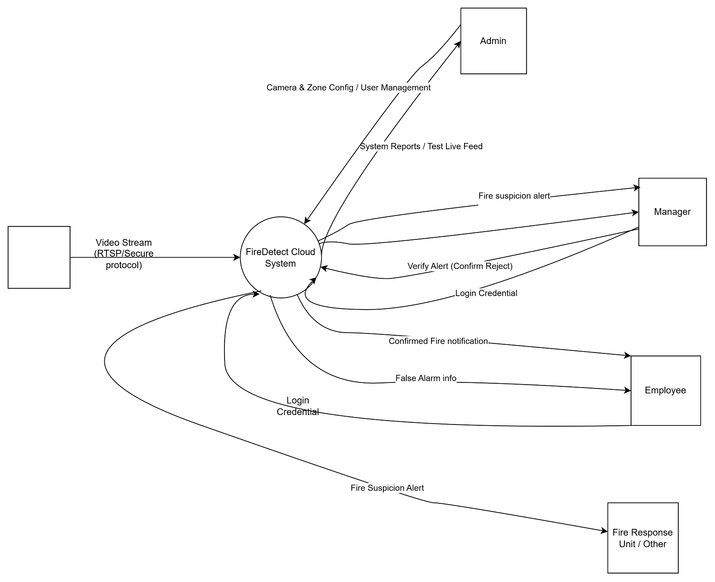
Context Diagram
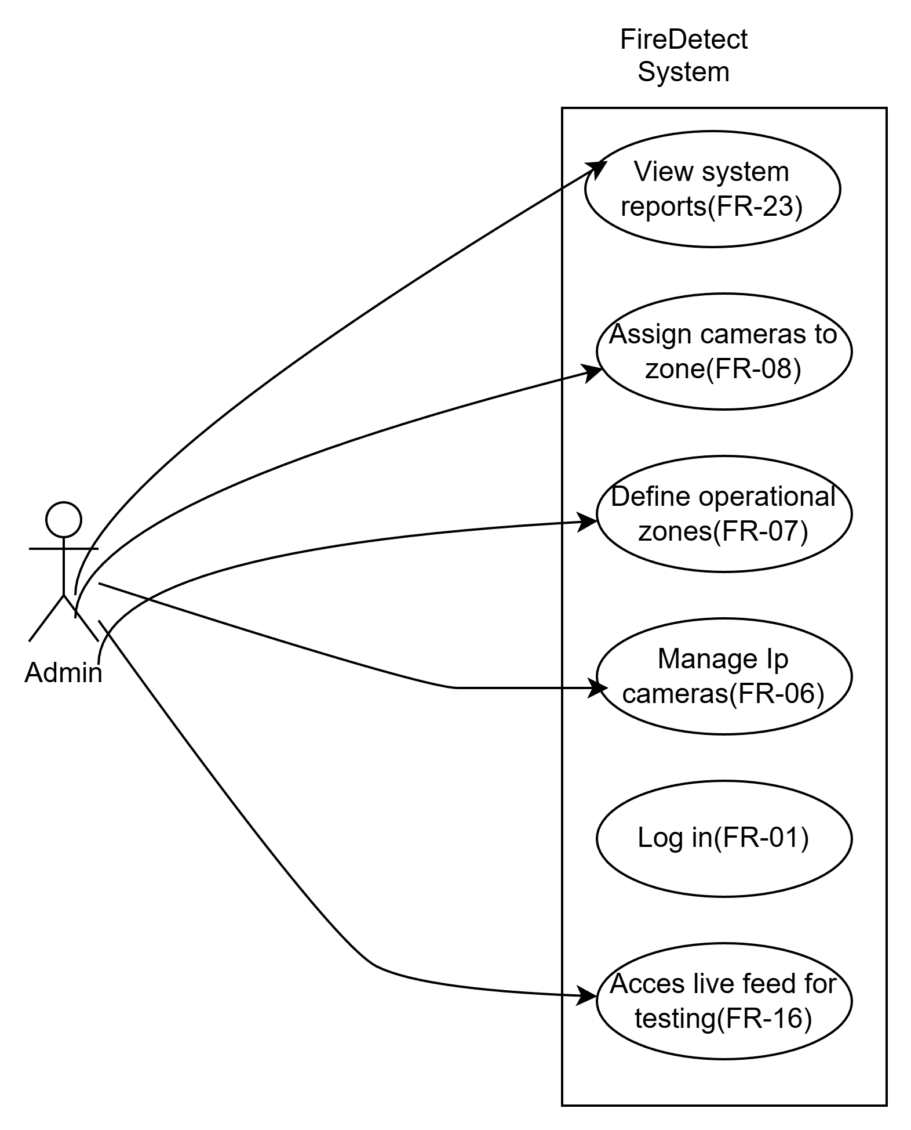
Admin Use case

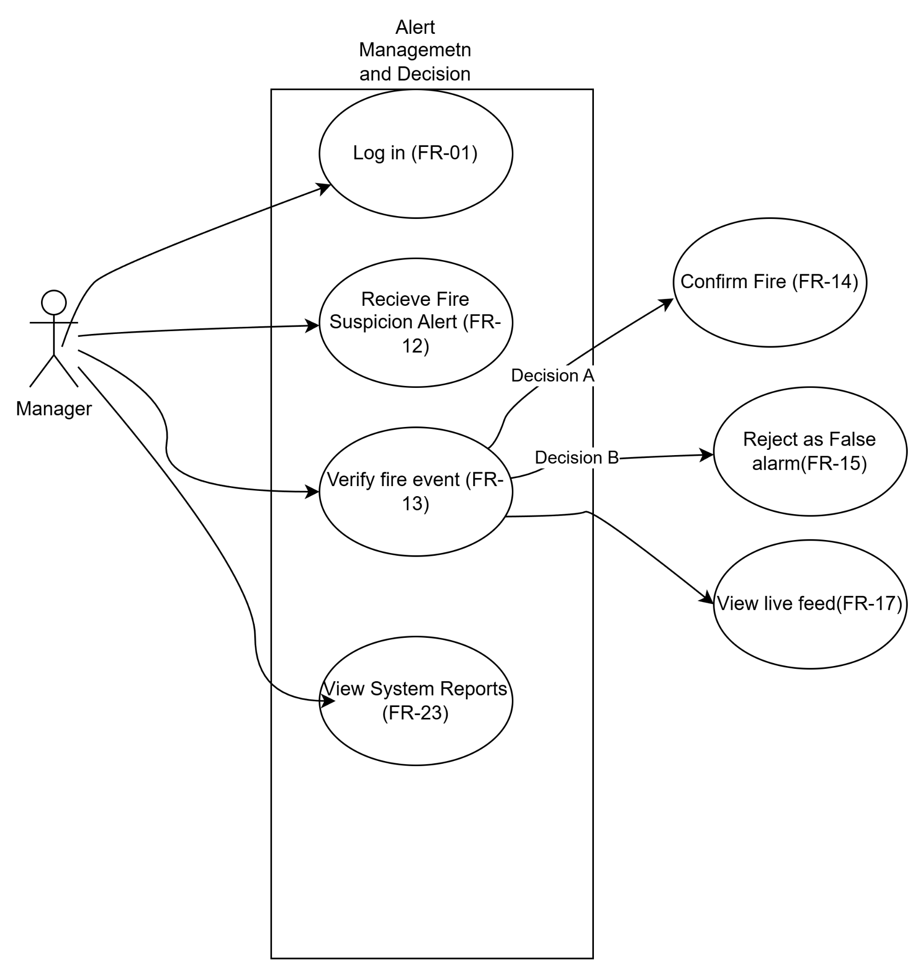
Manager useCase

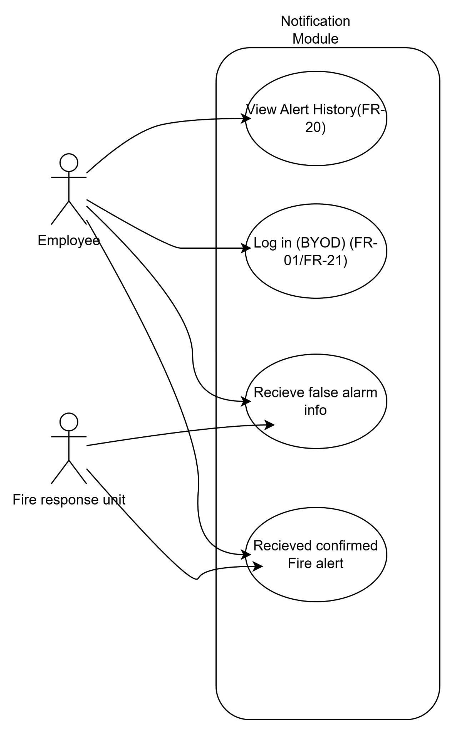
Employee and Fire unit use case

3.3.1 User & Access Management
FR-01 (Admin Only) – The Admin shall create user accounts and enable users to log in to the system securely. FR-02 – The Admin shall assign a role to each user from the following roles:
- Admin
- Manager
- Employee
- Other
FR-03 (Admin Only) – The Admin shall reset user passwords when required..
FR-04 (Admin Only) – The Admin shall control user access by assigning permissions based on user roles.
FR-05 (Admin Only) – The Admin shall ensure that users can access only the data belonging to their own organization.
3.3.2 Camera & Zone Management
FR-06 (Admin Only) – Admin shall add, edit, and remove IP cameras.
FR-07 (Admin Only) – Admin shall define operational zones (e.g., A Block, B Block).
FR-08 (Admin Only) – Cameras shall be assigned to zones by the Admin.
3.3.3 Fire & Smoke Detection
FR-10 – The system shall automatically analyze incoming camera images for fire and smoke detection.
FR-11 – The system shall classify detections as: Smoke Flame Smoke & Flame
3.3.4 Alerting & Notification
FR-12 – When the system detects a possible fire event in a zone (e.g., A Block), it shall generate a Fire Suspicion Alert and send it to:
- The Manager (with approval authority),
- The Employees of the related zone (e.g., A Block workers),
- The Other users / Fire Response Unit.
FR-13 – The system shall allow the Manager to:
- Approve the fire alert as Confirmed Fire, or
- Reject the alert as False Alarm.
FR-14 – If the Manager confirms the fire:
- The system shall send a fire alert notification to all employees across the entire company.
FR-15 – If the Manager marks the alert as False Alarm:
- The system shall send a false alarm notification only to:
  - The related zone (e.g., A Block employees),
  - The Other / Fire Response Unit.
- No company-wide alert shall be sent.
3.3.5 Live Camera Access
FR-16 – When there is no active fire alert:
- Only the Admin shall be always allowed to access live cameras for:
  - Camera testing,
  - System check purposes.
- Manager, Employee, and Other users shall NOT have live camera access during no active alarm.
FR-17 – When a Fire Suspicion Alert is generated:
- Only the Manager shall be able to:
  - Access the live camera of the related zone,
  - Visually verify the incident,
  - Approve or reject the alert.

After Decision
- If Confirmed Fire:
  - Every employee of the building receives notification.
  - NO live camera access is given to Employees or Other users.

- If False Alarm:
  - Only the related zone employees and Other users receive false alarm info.
  - Live camera access remains restricted.
FR-18 – Employees and Other users shall never access live camera streams under any condition.

3.3.6 Mobile Application Functions
FR-19 –Only the Manager shall be allowed to confirm or reject fire alerts.
FR-20 – Users shall view alert lists relevant to their assigned zone and role.
FR-21 (BYOD) – Users shall log in from their own personal mobile devices.

3.3.7 Logging & Reporting
FR-22 – The system shall log all major system events.
FR-23 – Admin and Manager shall access system reports.

3.4 Non-Functional Requirements
NFR-01 – Secure Communication
All data transmitted between IP cameras, cloud servers, and mobile applications shall be encrypted to prevent unauthorized access and data interception.
NFR-02 – Organizational Data Isolation
The system shall ensure strict data isolation between different organizations so that users can only access camera streams, alerts, and reports belonging to their own organization.
NFR-03 – Automatic Session Expiration
User sessions shall automatically expire after a period of inactivity in order to reduce the risk of unauthorized access, especially on personal mobile devices.
NFR-04 – Continuous System Availability
The system shall operate continuously (24/7) to provide uninterrupted fire monitoring and alerting services, except during scheduled maintenance periods.
NFR-05 – Low Latency Alert Delivery
Fire suspicion and confirmed fire alerts shall be delivered to users with minimal delay to support rapid decision making and emergency response.
NFR-06 – Usability for Non-Technical Users
The mobile application shall be easy to understand and use by non technical users such as factory workers and emergency response personnel.
NFR-07 – Scalability of Cameras and Users
The system shall support the addition of new IP cameras, zones, and users without requiring major changes to the system architecture.
NFR-08 – Clear Emergency Communication
Alert messages displayed in the mobile application shall be clear, concise, and easy to understand under emergency conditions.
NFR-09 – Data Storage Security Sensitive user data, particularly passwords and personal information, shall be stored in the database using strong hashing or encryption methods to prevent exposure in case of a data breach.
NFR-10 – Audit Log Integrity All system logs regarding alerts, user decisions (confirm/reject), and access history shall be stored securely and protected against unauthorized modification to ensure accountability.
NFR-11 – Detection Accuracy The fire detection algorithm shall be optimized to distinguish actual fire/smoke from similar visual elements (e.g., strong lights, steam) to minimize the rate of false alarms. (hocaya soralım)
NFR-12 – Fire Detection Latency The system shall detect fire or smoke events from incoming camera frames and produce a detection result within ≤ 2 seconds after the frame is received by the cloud server.
NFR-13 – Alert Delivery Latency Fire suspicion alerts shall be delivered to the relevant users’ mobile applications within ≤ 3 seconds after the detection decision is made.

NFR-14 – Manager Decision Response Time
After a Fire Suspicion Alert is generated, the system shall allow the Manager to access the live camera stream and submit an approve/reject decision with a system response time of ≤ 1 second per action.

NFR-15 – System Throughput
The system shall support simultaneous processing of video streams from at least N cameras without degradation in detection latency beyond defined limits.

NFR-16 – Detection Accuracy (hocanın özellikle sevdiği)
The fire detection algorithm shall achieve at least:
- ≥ 90% precision,
- ≥ 88% recall,
- ≤ 5% false alarm rate
under standard lighting and environmental conditions.

